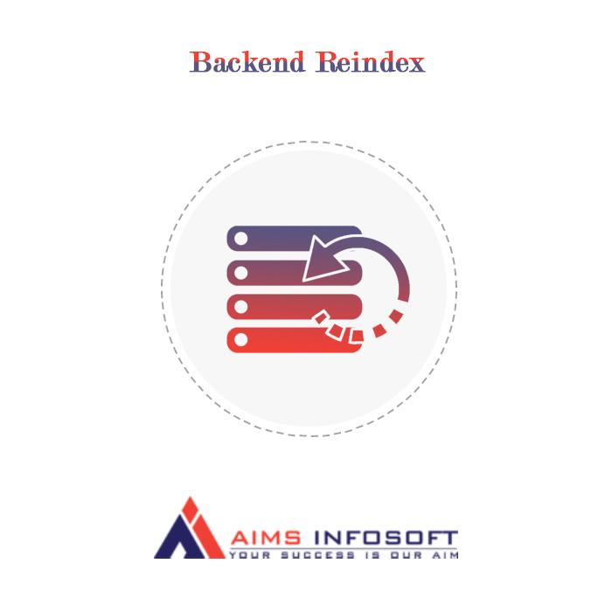

## ***Backend Reindex***

**Version : 1.0.0**

👉 Comaptibility:

* **Magento version : 2.3x, 2.4.x**
* **Module version : 1.0.0**
* **Supported browser : Chrome, Microsoft edge, FireFox**

👉 How To Install Backend Reindex ?

Install using composer :

1. **Composer require aimsinfosoft/backendreindex**
2. **Php bin/magento setup:upgrade**
3. **Php bin/magento setup:di:compile**
4. **Php bin/magento setup:static-content:deploy -f**

Install Manually :

1. **Download Extension from the** **Here**
2. **Add zip file in app/code folder and extract it and run below commands**
3. **Php bin/magento setup:upgrade**
4. **Php bin/magento setup:di:compile**
5. **Php bin/magento setup:static-content:deploy -f**

👉 How Backend Reindex works?

1. **From the admin backend, go to System >> Index Management**

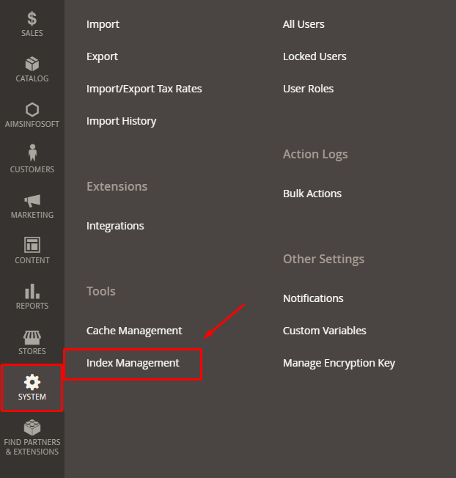

1. **Reindex one indexer:**

* **At the Action box, click on Reindex Data to reindex each indexer separately.**

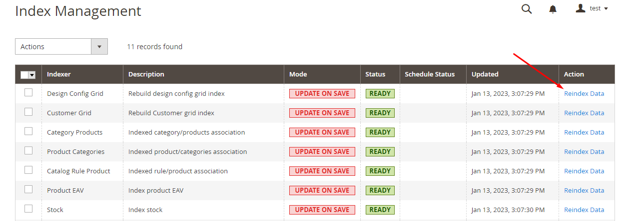

1. **Reindex some indexers :**

* **Click to select the indexers you need to reindex**
* **Select Reindex Data**
* **Click Submit**

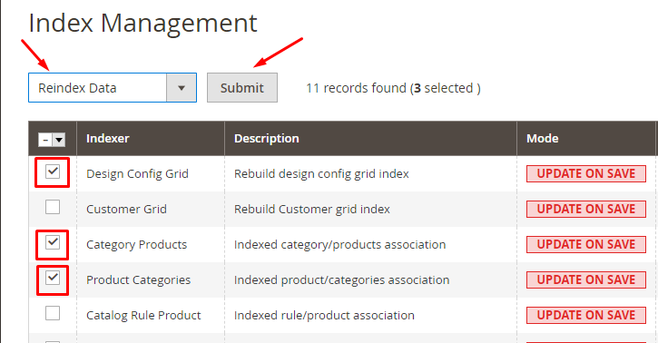

1. **Reindex all the indexers**

* **Click on Mass Actions box, choose Select All**

1. **Reindex all the indexers :**

* **Click on Mass Actions box, choose Select All**
* **Select Reindex Data**
* **Click Submit**

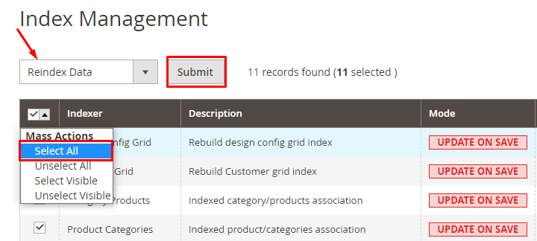

* **User roles with reindex**
* **Step 1 : Go to Admin > System > User Role**

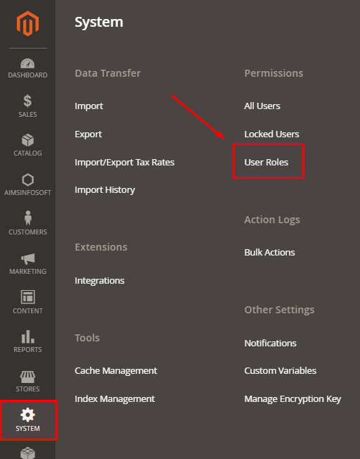

* **Step 2 : Add a new role resource**
* **Fill in role information at Role Information section**

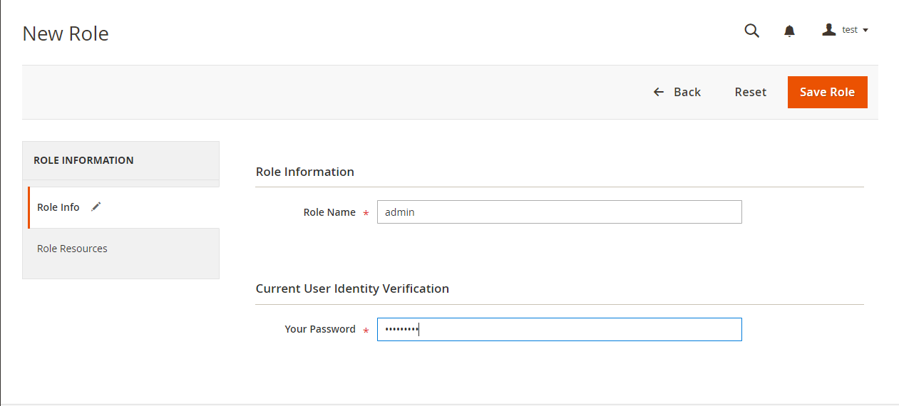

* **Select index management role at Role Resouces section, then click on Save Role**

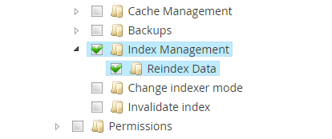

* **Step 3 : Set role users for admin accounts, then click on Save Role to finish.**

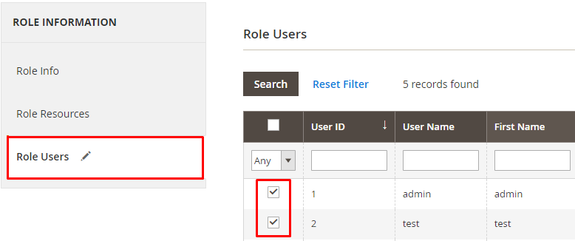

**If you any query or question than please contact us**

[**sales@aimsinfosoft.com**](mailto:sales@aimsinfosoft.com) **.**